GIT HOL
1.GIT-HOL

1. Objective
The objective of this hands-on lab is to understand the basic Git workflow, configure Git on a Windows machine, create and initialize a local Git repository, create and track a file, commit changes, connect the local repository to GitHub, and push the changes to a remote repository.

2. Prerequisites
- Git Bash installed on the Windows machine.
- A GitHub account.
- Access to the CTS-Digital-Nurture GitHub repository.
- Basic familiarity with Git commands.

3. Tools and Technologies Used
- Git 2.51.0 for Windows
- Git Bash
- GitHub
- Visual Studio Code configured as the Git editor

4. Verify Git Installation
The Git installation was verified using the following command:
git --version
Output:
git version 2.51.0.windows.1

5. Configure Git User Information
Git was configured with the user name and email address using:
git config --global user.name "Manasa"
git config --global user.email "manasachowdary237@gmail.com"
The configuration was verified using:
git config --global --list
The verified configuration included:
user.name=Manasa
user.email=manasachowdary237@gmail.com
Visual Studio Code was already configured as the default Git editor.
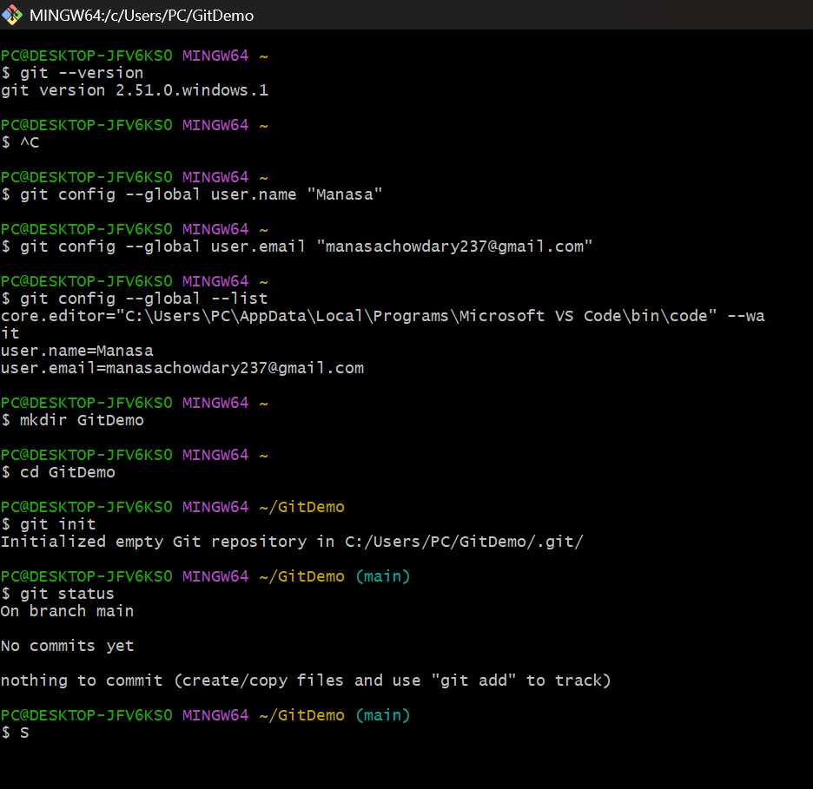

6. Create and Initialize the Local Repository
A local Git repository named GitDemo was created. The repository was initialized using the following command:
git init
The repository was then checked using git status to confirm that it was initialized correctly.
git status

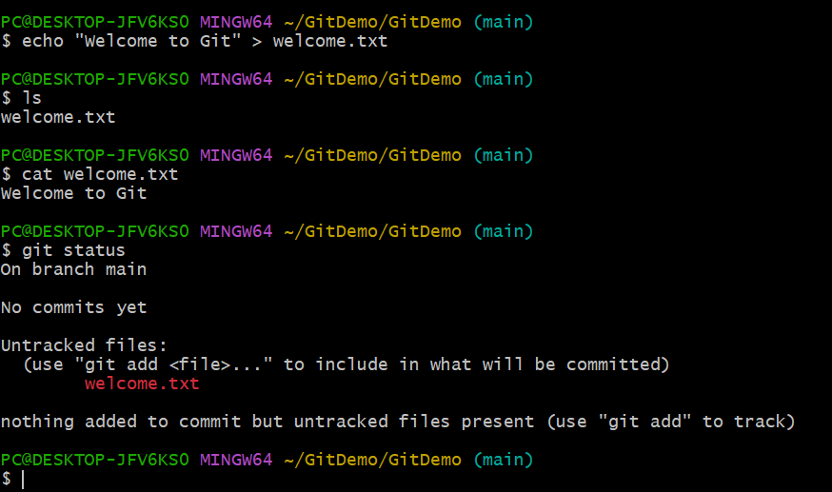

7. Create the welcome.txt File
A file named welcome.txt was created in the GitDemo repository with a welcome message.
echo "Welcome to Git" > welcome.txt
The file was verified using:
ls
The contents of the file were checked using:
cat welcome.txt
The repository status was then checked:
git status
At this stage, welcome.txt was identified by Git as an untracked file.
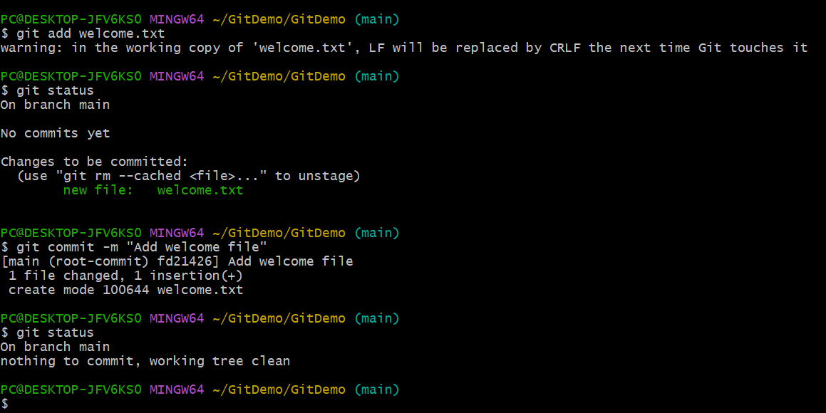

8. Stage the File
The welcome.txt file was added to the staging area using:
git add welcome.txt
The staging status was verified using:
git status

9. Commit the Changes
The staged file was committed to the local Git repository using:
git commit -m "Add welcome file"
The repository status was checked after the commit using:
git status
The working tree was clean after the commit, confirming that the changes were successfully committed.

10. Add the Task to CTS-Digital-Nurture
The existing CTS-Digital-Nurture repository was used for the final submission. The Git task file was placed in the existing DeepSkilling Module08 folder.
CTS-Digital-Nurture/DeepSkilling/Module08/welcome.txt
The file was verified with git status. The output showed the following untracked file:
DeepSkilling/Module08/welcome.txt
This confirmed that the task was ready to be added to Module08 without modifying the other modules.

11. Stage, Commit and Push
The Module08 file was staged using:
git add DeepSkilling/Module08/welcome.txt
The changes were committed using:
git commit -m "Add Git hands-on lab to Module08"
Finally, the changes were pushed to the GitHub remote repository using:
git push origin main
The push completed successfully, and the file became available in the GitHub repository at:
CTS-Digital-Nurture → DeepSkilling → Module08 → welcome.txt

12. Final Repository Structure
The completed task was stored in the following location:
CTS-Digital-Nurture/
└── DeepSkilling/
└── Module08/
└── welcome.txt

13. Result
The Git hands-on lab was successfully completed. Git was installed and configured, a local repository was initialized, welcome.txt was created and tracked, the changes were committed, and the completed task was pushed successfully to the existing CTS-Digital-Nurture GitHub repository under DeepSkilling/Module08.

